AI Prompt Log – Cafe Delight Website
Student Name: Hajra Rizwan Roll Number: 26I-3052
Section: SE-B
Prompt 1: Planning the Website
Prompt:
I am working on my Lab 12 project for a cafe website called Cafe Delight. I want to turn my Lab 11 page into a complete website with multiple pages. Please suggest suitable pages that match my cafe theme and keep the design consistent.
Result:
ChatGPT suggested creating Home, Menu, Gallery, and Contact pages. I decided to use these pages because they fit my website theme.
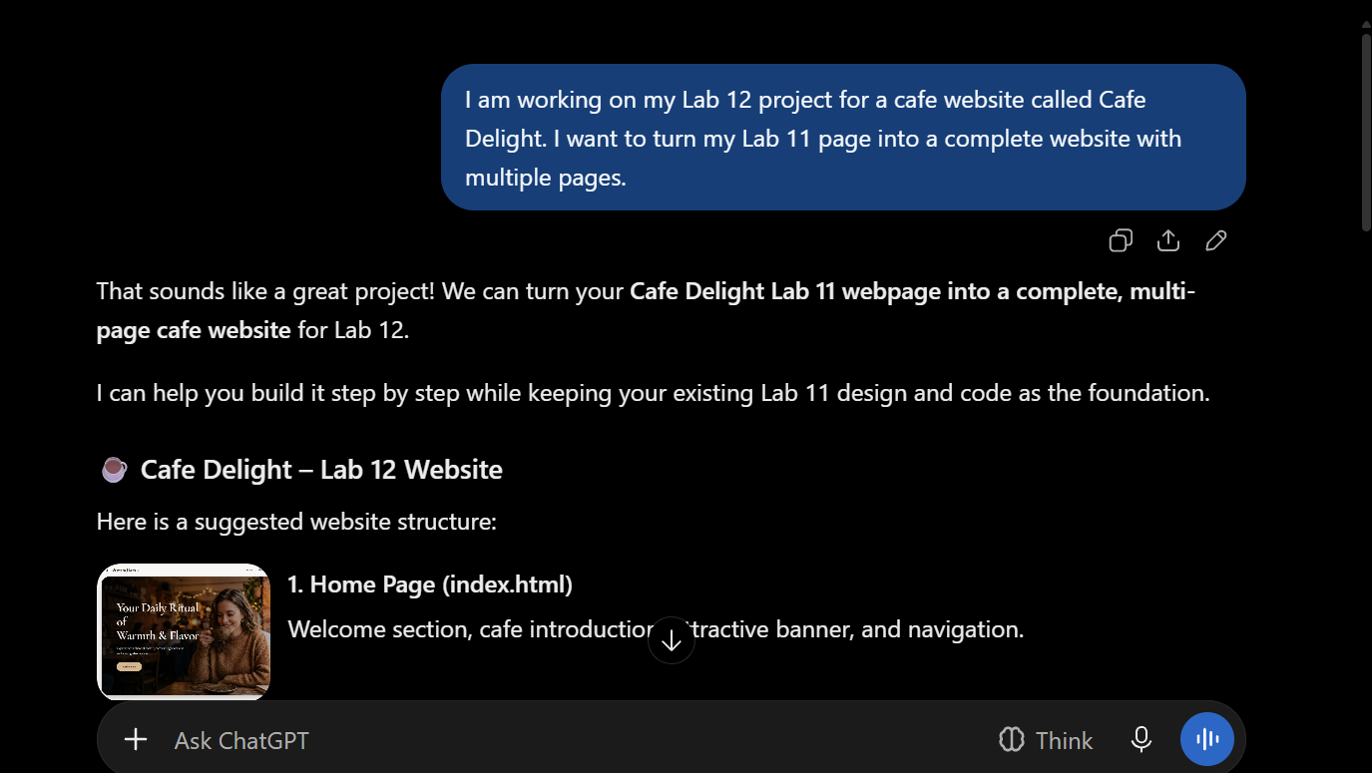
Prompt 2: Creating the Website Pages
Prompt:
Help me create a simple cafe website using HTML and CSS. I need separate Home, Menu, Gallery, and Contact pages. Keep the same colours, fonts, navigation bar, and overall design on every page.
Result:
ChatGPT helped me create the website pages and organize their content. I added the files to my project folder and checked them in the browser.
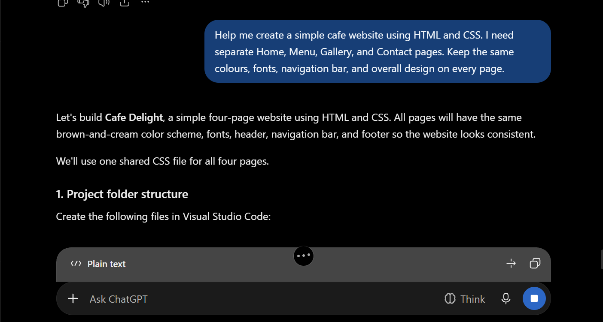
Prompt 3: Improving the Website Design
Prompt:
Help me improve the appearance of my Cafe Delight website. Make the layout more attractive, keep it responsive, and make the coffee image larger.
Result:
ChatGPT helped improve the CSS styling and image size. I also adjusted the image path to make sure the coffee image displayed correctly.
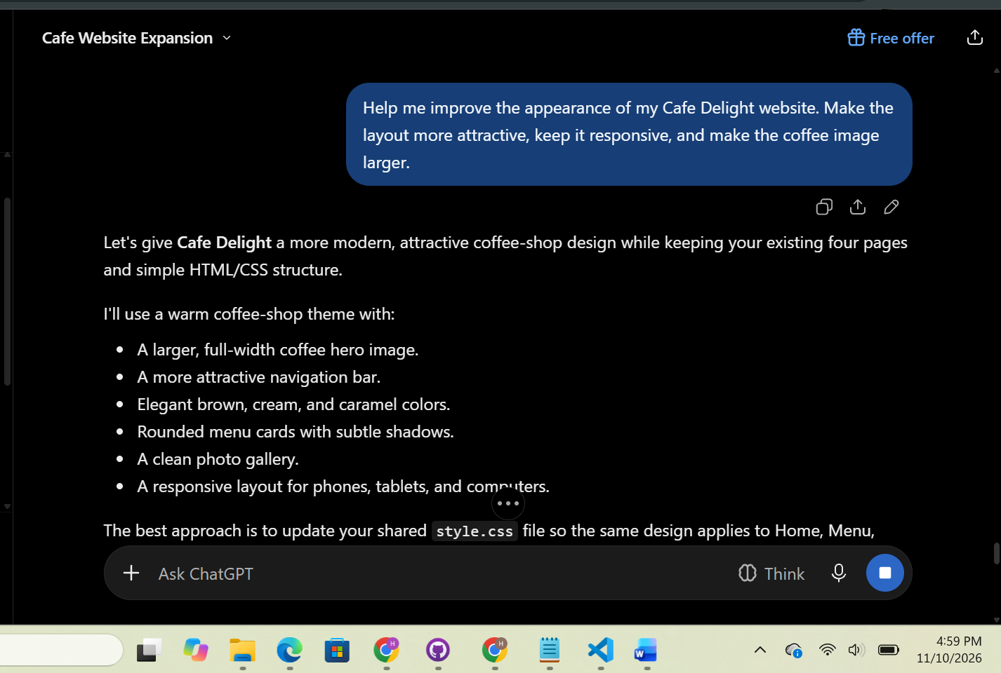
Prompt 4: Updating the README
Prompt:
Help me write a README file for my Cafe Delight project. Include my project details, website theme, page names, AI tool used, and live website link.
Result:
ChatGPT prepared a README with the project information and live website link. I added it to my repository.


